***Browser control :***

*Directing from one page to another :*

            <a href="#" onClick="window.location.assign('http://127.0.0.1:5500/anohter.html#guarantee');">Click</a>

*Go forward or backward :*

go forward

            <input type="button" value="Click" onClick="history.forward();">

   go backward !

            <input type="button" value="Click" onClick="history.back();">

*Web reload :*

<a href="#" onClick="window.location.reload(true);">Click</a>

***Filling the window with content as directed to the next page :***

know manipulation worth

            <input type="button" value="Click" onClick="woho()">

Its function :

function woho(){

    var monkeyWindow = window.open();

var windowContent = "something will happen";

monkeyWindow.document.write(windowContent);

}

***Controlling size of window and location:***



Example code :

        <input type="button" value="Press" onclick="window.open('function sayHi();', 'win1','width=420,height=380');">

***Testing for popup blockers:***

Popup blockers are now a standard feature of browsers, with some level of popup blocking usually built in as a default. JavaScript popups, and especially those that open a new page within the same website, are often tolerated by default, but you can never be sure. If popups are an essential feature of your site, you need to test whether your popups are going to be blocked. If they are, you can ask the user to disable the popup blocker for your site.

    <body onLoad ="checkForPopBlocker();">

 function checkForPopBlocker() {

     var testPop = window.open("", "","width=100,height=100");

     if (testPop === null) {

    alert("Please disable your popup blocker.");

     }

     testPop.close();

     }

***Form Validation :***

***Setting up conditions in text field:***

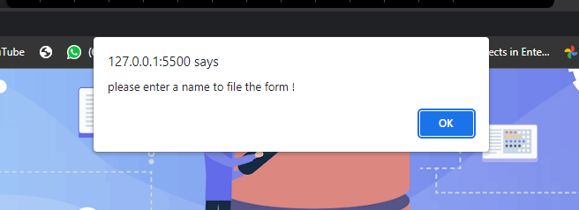



If we click directly without filling the form textfield this happens as above pictures shown.

submit a form with your cnic

    <form onsubmit="return checkforlastnameanditscolor();">

        please enter your last name.<br>

        <input type="number" id="lastnamefield">

        <input type="submit" value="Submit Form">

    </form>

  function checkforlastnameanditscolor(){

        var targetfield=document.getElementById("lastnamefield");

        if(targetfield.value.length===0){

            alert("please enter a name to file the form !");

            targetfield.focus();

            targetfield.style.background="Yellow";

            return false;

        }

        else if(targetfield.value.length!==13 ){

            alert("please enter cnic under length of 14 digits !");

        }

        targetfield.style.background="White";

        document.write("Thankyou for filling out our form !");

    }

***Dropdowns:***

Examples :

    <form onSubmit="return checkForSelection();">

        <select id="states">

        <option value="" selected="selected">

        SELECT A STATE</option>

        <option value="AL">Alabama</option>

        <option value="AK">Alaska</option>

        <option value="AZ">Arizona</option>

        <option value="AR">Arkansas</option>

        </select>&nbsp;&nbsp;

        <input type="submit" value="Submit Form">

        </form>

    function checkForSelection() {

         if (document.getElementById("states").selectedIndex === 0) {

         alert("Please select a state.");

         return false;

         }

         else {

            alert("selection done",states);

         }

         }

Example 02 :

Just change event handler in markeup:

Top of Form

Top of Form

Top of Form

Top of Form

Top of Form

         <form onSubmit="return checkForSelection('states');">

With modifications in the function as follows :

   function checkForSelection(selecID) {

             var target = document.getElementById(selecID);

            if (target.selectedIndex === 0) {

             alert("Please select a state.");

             return false;

            }

             }

***Radio buttons:***

 <form onsubmit="return checkbutton();">

    <input type="radio" name="r1" value="karachi"> karachi<br>

    <input type="radio" name="r1" value="lahore"> Lahore<br>

    <input type="radio" name="r1" value="islamabad"> islamabad<br>

    <input type="submit" value="Submit Form">

</form>

     function  checkbutton(){

        var button=document.getElementsByName("r1");

        for(var i=0;i<button.length;i++){

            if(button[i].checked){

                return true;

            }

        }

        alert("please check a button !");

        return false;

       }

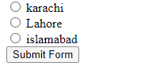

*If button is not check*



***Check for valid entry in the text field :***

   function validateZIP() {

             var valueEntered = document.getElementById("zip").value;

             var numChars = valueEntered.length;

            if (numChars < 5) {

             alert("Please enter a 5-digit code.");

            return false;

            }

            for (var i = 0; i <= 4; i++) {

             var thisChar = parseInt(valueEntered[i]);

             if (isNaN(thisChar)) {

            alert("Please enter only numbers.");

             return false;

             }

             }

             }

Just make a form for that and a text field alongwith call a function as shown above on it.

We have alternate in the form for that instead of choosing text we choose number which do the same thing when user accidentally tries to enter alphabet or special characters the textfield wont let user enter that input but just numbers as the textfield in itself we defined it as a number. 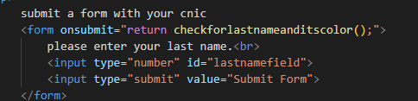



***Check for valid Email entry in the text field :***

<form onsubmit="return checkemail();">

        please enter your email.<br>

        <input type="email" id="efield">

        <input type="submit" value="Submit Form">

    </form>

      function checkemail(){

        var checkillegaladdress=true;

        var checkemail=document.getElementById("efield").value;

        if(checkemail.indexof(" ") !==-1){

            checkillegaladdress = false;

        }

        if(checkemail.indexof("@") < 1 || checkemail.indexof("@") > checkemail.length - 5 ){

            checkillegaladdress = false;

        }

        if (eEntered.indexOf(".") - eEntered.indexOf("@") < 2 || eEntered.indexOf(".") > eEntered.length - 3) {

            checkillegaladdress = false;

 }

 if(checkillegaladdress===false){

    alert("Please enter email in correct format !");

    return false;

 }

 else {

alert("Email submitted !");

}

      }